All Time AIL Team
15) Denis Hurley 2012- 2017
Dolphin appearances 5
Munster appearances 166 Tries 16
Ireland Caps 1

Capped for Ireland 3 years before joining Dolphin, his last appearances in 2016-17 were when he was the Dolphin backs coach.
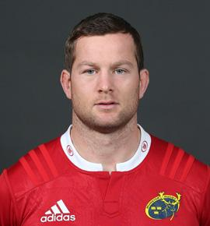
14) Mick Kiernan 1991-1994
Dolphin appearances 17 Tries 1 Pens 29 Cons 12 DG 3
Munster appearances
Ireland Caps 43 308 points (6 tries, 40 con,6 dg, 62pen)
Lions Tests 4
Barbarians appearances 5 19 points
Dolphin Senior Captain 1991-92

Joined Dolphin from PBC and played in the Munster Senior League for many years before the AIL. Dolphin’s most capped international, his records there speak for themselves. Mick the Kick scored the winning drop goal to clinch the Grand Slam, he may have made only 17 AIL appearances yet is still the 3rd highest drop goal scorer for Dolphin. Two of them came in the opening AIL game a victory over Blackrock College.
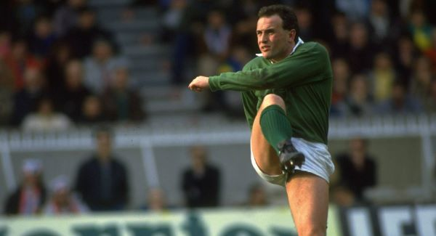
13) Cian Bohane 2009-2016
Dolphin appearances 68 Tries 12
Munster appearances 9 Tries 1

Joined Dolphin from school and quickly established himself as a starter on the senior team while still also in the U20 squad. His AIL performances earned him a place in the Munster Academy and went on to a full Munster Contract.
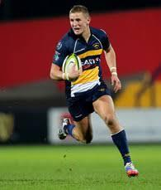
- Rory Scannell 2012-
Dolphin appearances 26 Tries 5 Pen 19 Cons 11
Munster appearances 124 Points 149
Ireland Caps 2 Cons 3

One of the most versatile players ever to play for Dolphin, has started at 10,11,12,13 & 15 in 26 games.
Became the first player to win Munster Academy & Young Player of the Year awards. Niall & Rory became the first Munster brothers to play together on the Irish side in the Professional era. Always a great man for the long-range penalty. Youngest player to reach 100 appearances for Munster (at 25)
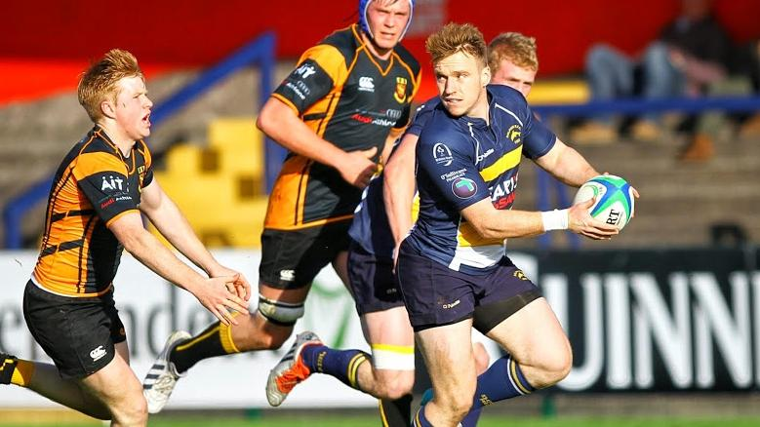

- Jack Clarke 1991-96
Dolphin appearances 46 Tries 9
Munster appearances
Ireland Caps 5 Tries 1

Jack was capped at every level, Schools, U/21, U/23, B, and Senior. He scored a try on his senior international debut v Wales in 1991. Only player to have played U18 for Dolphin the year after playing international schools.

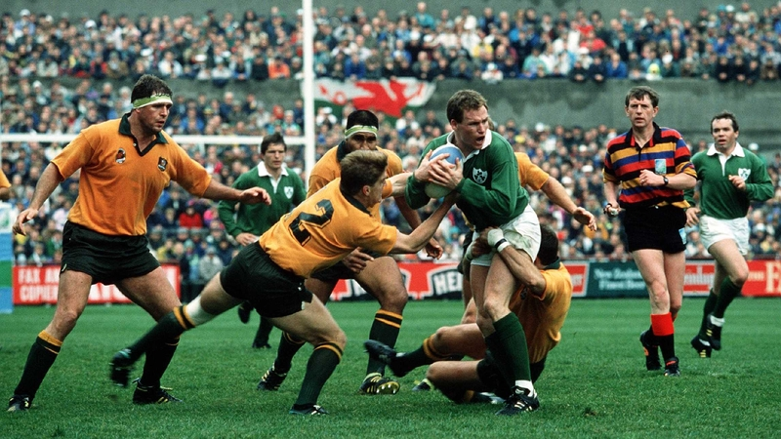

10) Barry Keeshan 2005-18
Dolphin appearances 195 Tries 5 Pens 344 Cons 230 DG 39
Dolphin Senior Captain 2009-10, 2010-11

Scoring over 1600 points for Dolphin, there was no way he would not be in everyone’s team. Keesh set many records, highest points scorer in the AIL, until this year leading appearances in Club international side (10) Answered the call so many times for Dolphin, including in a Senior Backs coach role in 2017.
Capped at Ireland U20’s (keeping Johnny Sexton on the bench for a while) Made the Munster Squad for a couple of Celtic League games but was unlucky not to get game time.
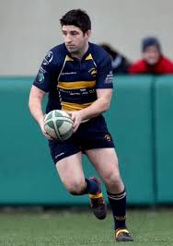

9) Tomás O’Leary 2004- 2016
Dolphin appearances 23 Tries 12
Munster appearances 145 Tries 10 Con 2 Pen 1
Ireland Caps 24 Tries 3

Joined Dolphin following 2004 U21 World Cup final. 11 of his Dolphin appearances came in that first season, scoring six tries in his first four games.
Member of the 2009 Grand Slam side, selected for the Lions to South Africa but unfortunately was unable to travel through injury.
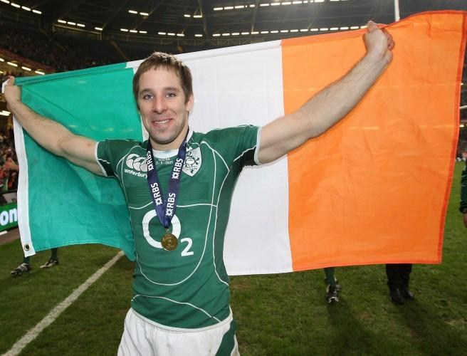

- Dave Ryan 2008- 2011
Dolphin appearances 36 Tries 4
Munster appearances 10

Dave played for Dolphin for 3 seasons before he headed to Italy to play professionally for 3 years. He returned to Ireland to Ulster for a year before joining Agen. He has been with the Top 14 side for the past 5 seasons.

- Niall Scannell 2010-
Dolphin appearances 59 Tries 11
Munster appearances 103 Tries 11
Ireland Caps 20 Tries 1
Dolphin Senior Captain 2012-13

Captained Ireland U20’s at the Junior World Cup in 2012 and has also captained Munster. He has an excellent win ratio with Ireland, 85% 17/20, with losses against New Zealand & Wales twice.
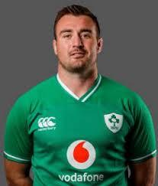
- Christy Condon 2007-14
Dolphin appearances 106 Tries 8
Dolphin Senior Captain 2013-14

Christy joined from Midleton and was such an important front row player for six seasons. Member of the Hundred Club, he made 6 appearances for the Irish Club side and was an unused substitute on another occasion. Based on these performances he earned a training contract and later a development contract with Munster.
- John Madigan 2012- 2017

Dolphin appearances 23 Tries 2
Munster appearances 3

A product of the Munster Youths system, the Charleville man played for the Irish U18 side for two years. Selected for U20 World Cup but withdrew from the squad due to illness. During the years of his Munster Academy & Development contract he was very unfortunate and following his release in 2017 he moved to RC Massey, where he is in his 3rd season.
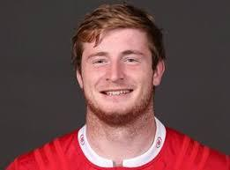

- Rob O’ Herlihy 2010 -18
Dolphin appearances 122 Tries 3
Joined from PBC and established himself in the Senior side in the first season and made 122 appearances over the following eight seasons. Equally comfortable in the 2nd row or backrow.
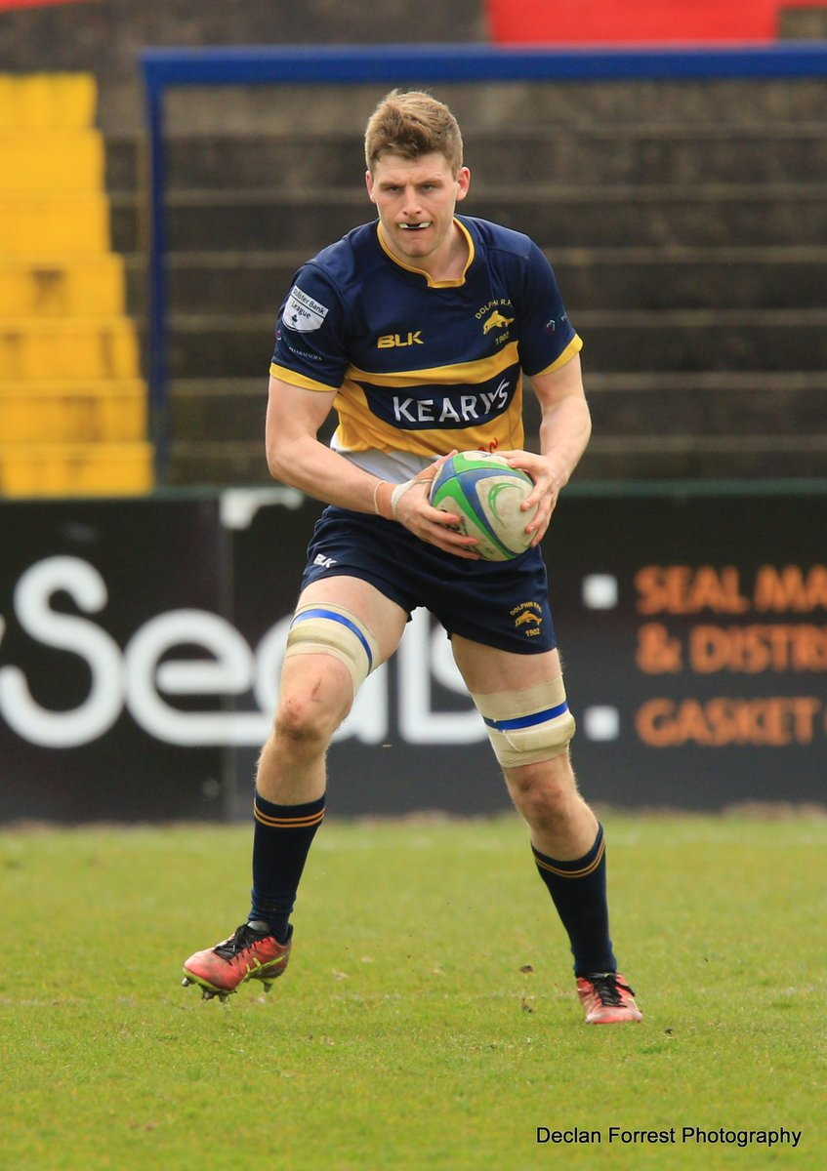

- Dave O’Callaghan 2010-18
Dolphin appearances 28 Tries 2
Munster appearances 85 Tries 5

The Youghal man played both 2nd row and backrow. He played in 2 U20 World Cups and also for the Emerging Ireland side. He was unfortunate with a couple of serious knee injuries which kept his Munster appearances to less than 100. Things are going well for Dave this season, starting 18/23 games for Biarritz in French D2, playing the full 80 in 13 of the games.
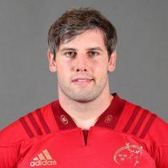

- John Quill 2010 - 2015

Dolphin appearances 50 Tries 10
USA Eagles 37 Tries 5

Always looking to make a career of rugby, when playing with Dolphin he was unable to get a Munster contract. Played in UK and USA returning each time to Dolphin where he was player of the year on a couple of occasions before he established himself on the Eagles side. Selected for 2 Rugby World Cups, his favourite try was no doubt the one he scored against Ireland.
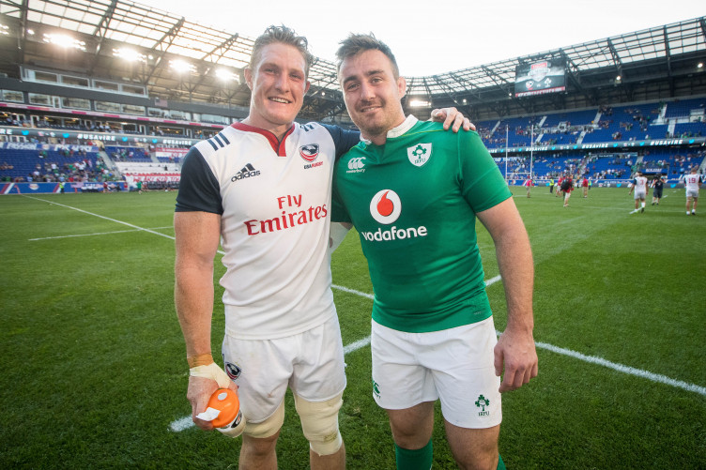

- James Coughlan 2001- 2011
Dolphin appearances 101 Tries 37
Munster appearances 137 Tries 13
Dolphin Senior Captain 2004-05 & 2005-06

Like Terry before him he captained Munster in a victory over Australia and also captained the Irish Wolfhounds. Munster Player of the Year 2011. Also represented Irish Universities and Ireland 7’s.
Dolphin were well aware of his excellent talent before Munster finally gave him a Development Contract. He had scored more tries than any other Dolphin player in the AIL, before he started with Munster. Moved to Pau, after 3 seasons and 69 appearances, started his coaching career taking over the Academy and is currently forwards coach for Provence.
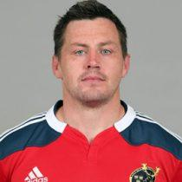

Substitutes

16) Terry Kingston 1991- 1998
Dolphin appearances 63 Tries 1
Dolphin Senior Captain 1988-89 & 1989-90
Munster appearances
Ireland Caps 30 Tries 2
Barbarians appearances 3
Joined from CBC, Terry played in the Munster Senior League for Dolphin for many years before the AIL commenced. Played in the clubs first AIL games, retiring following the clubs first season in Division 1. Played in 3 World Cups, captaining Ireland in the 1995 World Cup.
Played for Munster in the amateur era, led Munster to victory over Australia.
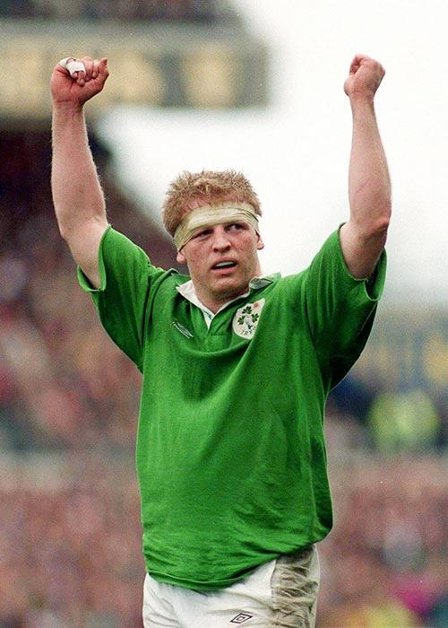

17) James Cronin 2011-13
Dolphin appearances 30 Tries 3
Munster appearances 124 Tries 17
Ireland Caps 3

James joined Dolphin when he was in the Munster Academy, after 2 years made his Senior debut v Leinster, voted Academy Player of the Year, and was awarded a Development Contract. Before he had completed this contract, he had earned his Ireland debut.
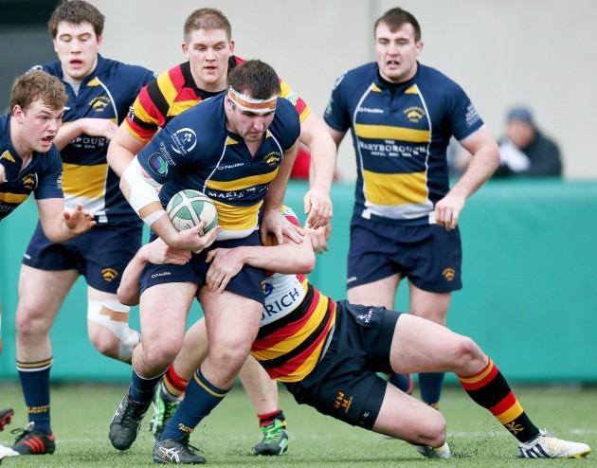

18) John O’Sullivan 2000-07

Dolphin appearances 96 Tries 4

What is it with West Cork props and finishing on 96 appearances, like Eddie Knowles, Kinsale man John O’Sullivan made 96 appearances, however it took him two seasons less.

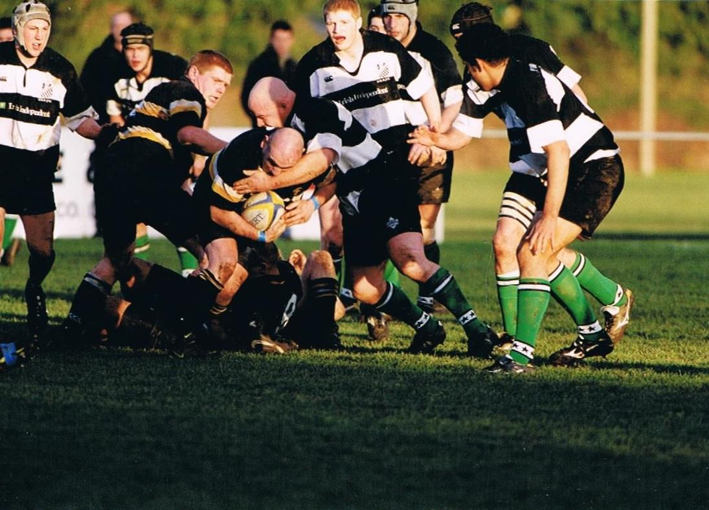

19) Shane Madigan 2001-04
Dolphin appearances 38 Tries 9

No.6 - Shane had 3 very good seasons with Dolphin before transferring to Blackrock College.
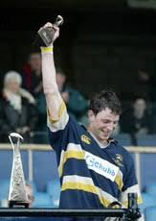

20) Nick Williams 2009-10

Dolphin appearances 5 Tries 1
Munster appearances 19 Tries 4

Nick played for the Junior All Blacks, a couple of seasons before joining Munster. His two seasons with Munster were not the highlight of his career. However, after a better year with Aironi he joined Ulster where he was a firm favourite in his 3 seasons and has been equally successful in Cardiff where he is in his 4th season. Normally a No. 8 but in his 3 games alongside James Coughlan in Dolphin colours he played No 6 twice.
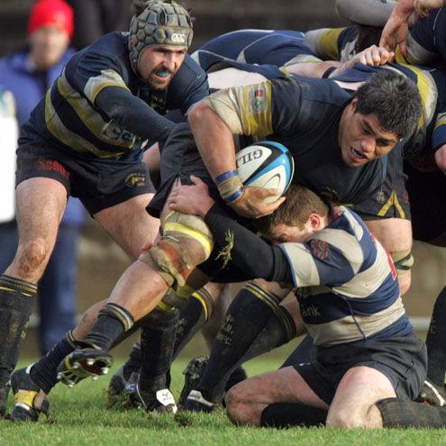

21) Dave O’ Mahony 2002-03

Dolphin appearances 16 Tries 1
Munster appearances 4
Leinster appearances 7 Tries 2
Ireland Caps 1
Dave earned his international cap in 1995. Played for just one season with Dolphin but spent longer as Senior coach. Like another Dolphin scrum half, Gus Aherne, he played more times for Leinster than Munster.
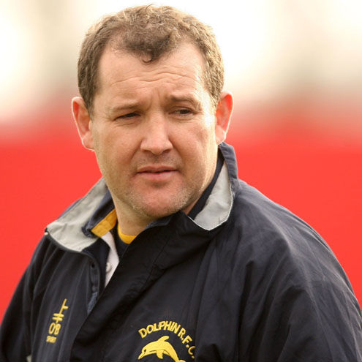

22) Conor Mahony 1994-98

Dolphin appearances 40 Tries 12 Pens 46 Cons 29
Munster appearances 25 Points 125

Conor was outhalf for the promotion winning Division 2 side in 1996/97, he was the player of the season, scoring 10 tries and a total of 158 points in 13 games. Also, an accomplished centre, moved to Cork Constitution before work brought him to Dublin and he joined Clontarf

23) Darren Sweetnam 2013-14

Dolphin appearances 13 Tries 3
Munster appearances 83 Tries 19
Ireland Caps 3 Tries 1
With Dolphin for just the one season, earned his first international cap two years later. Munster’s Young player of the Season 2017. Not many players have represented their country in three different sports as well as play Senior Championship Hurling.
