There were a number of close calls, in particular at 14, 8 at 17 – see below.

Club Team
15) Eamonn Mills 2011- 2015
Dolphin appearances 61 Tries 11 Pen 1 Cons 3
Joining from PBC, he continued to impress and improve, and Lansdowne were very fortunate work brought him to Dublin. Was awarded the UBL Leinster Club Player of the Year in 2017. Went on to earn 5 Club International caps.
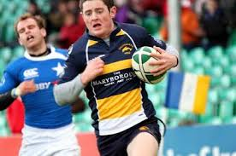
14) Mike Pettman 2002-2004
Dolphin appearances 18 Tries 9 Pens 7 Cons 2
Mike had represented Manawatu and New Zealand Universities and had been training with the New Zealand 7’s side before he came to Cork. His last game in NZ was for a New Zealand Divisional side v Ireland. He was a very important member of the Squad that lifted the Division 2 trophy but unfortunately missed the final at Lansdowne Rd through injury. While he returned to NZ after two seasons, he came back last July as the Munster Technical Skills Development Coach.
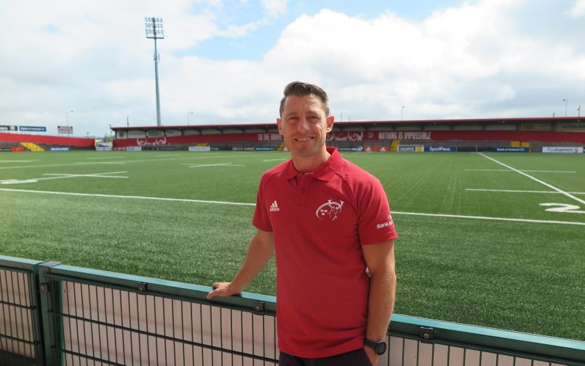
13) Eric Moloney 2006- 2014
Dolphin appearances 73 Tries 19
Dolphin Senior Captain 2011-12

73 appearances, all starts, Eric was a very solid centre. Represented the Irish Club International side 5 times when with Dolphin.
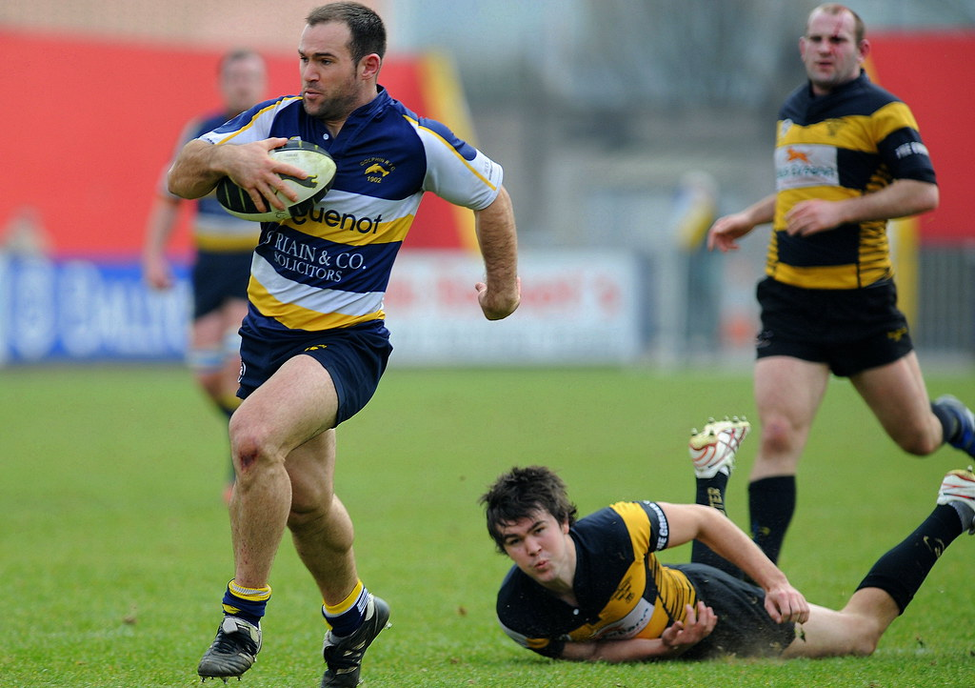
12) Mick Kiernan 1991-1994
Dolphin appearances 17 Tries 1 Pens 29 Cons 12 DG 3
Munster appearances
Ireland Caps 43 308 points (6 tries, 40 con,6 dg, 62pen)
Lions Tests 4
Barbarians appearances 5 19 points
Dolphin Senior Captain 1991-92

Joined Dolphin from PBC and played in the Munster Senior League for many years before the AIL. Dolphin’s most capped international, his records there speak for themselves. Mick the Kick scored the winning drop goal to clinch the Grand Slam, he may have made only 17 AIL appearances yet is still the 3rd highest drop goal scorer for Dolphin. Two of them came in the opening AIL game a victory over Blackrock College.
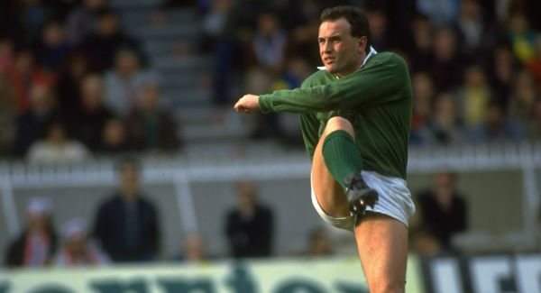
- Jack Clarke 1991-96
Dolphin appearances 46 Tries 9
Munster appearances
Ireland Caps 5 Tries 1

Jack was capped at every level, Schools, U/21, U/23, B, and Senior. He scored a try on his senior international debut v Wales in 1991. Only player to have played U18 for Dolphin the year after being capped for the international school’s side.
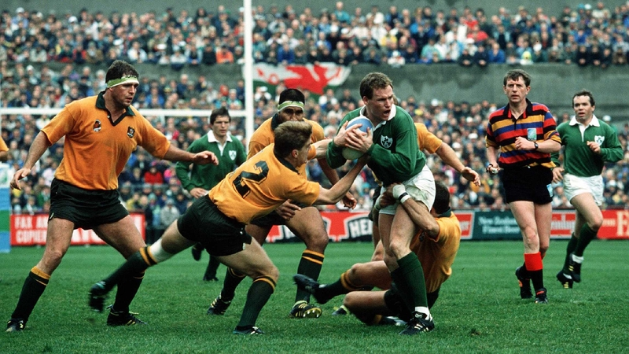

10) Barry Keeshan 2005-18
Dolphin appearances 195 Tries 5 Pens 344 Cons 230 DG 39
Dolphin Senior Captain 2009-10, 2010-11

Scoring over 1600 points for Dolphin, there was no way he would not be in everyone’s team. Keesh set many records, highest points scorer in the AIL, until this year leading appearances in Club international side (10) Answered the call so many times for Dolphin, including in a Senior Backs coach role in 2017.
Capped at Ireland U20’s (keeping Johnny Sexton on the bench for a while) Made the Munster Squad for a couple of Celtic League games but was unlucky not to get game time. 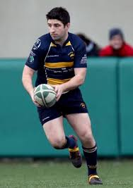

9) Dave O’ Mahony 2002-03

Dolphin appearances 16 Tries 1
Munster appearances 4
Leinster appearances 7 Tries 2
Ireland Caps 1
Scrum Half- Dave earned his international cap in 1995. Played for just one season with Dolphin but spent longer as Senior coach. Also coached Club International side
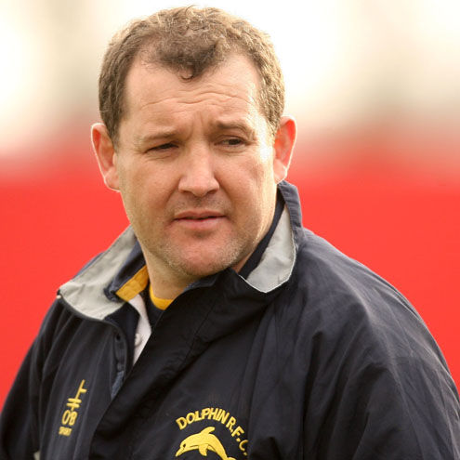

- Eddie Knowles 1995- 2004
Dolphin appearances 96 Tries 6
Dolphin Senior Captain 2001-02

Eddie finished with 96 appearances, returning to Clonakilty, had he played on he would have been the first player to reach 100 appearances for Dolphin.
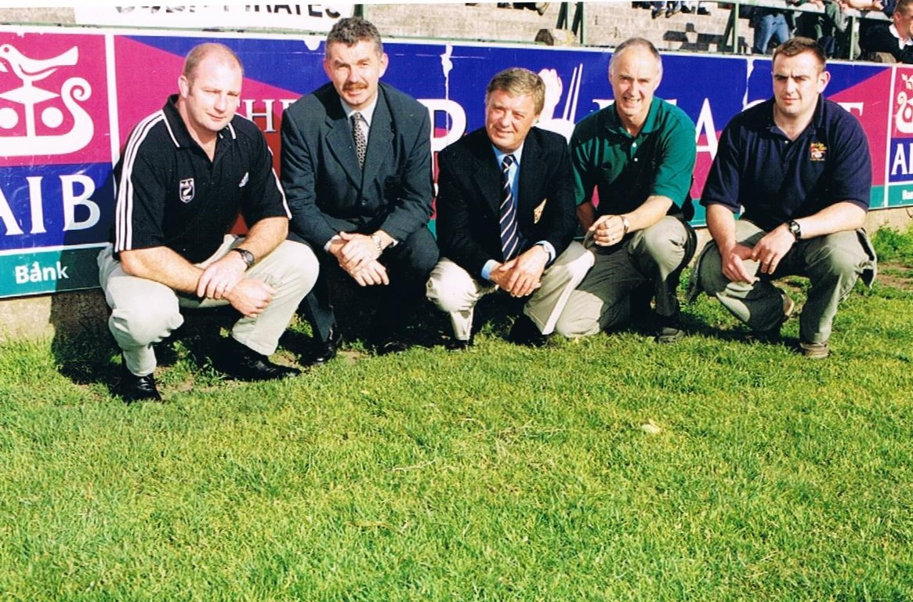
Eddie pictured far right with Coaching and Management Team 2001-02

- Terry Kingston 1991- 1998
Dolphin appearances 63 Tries 1
Dolphin Senior Captain 1988-89 & 1989-90
Munster appearances
Ireland Caps 30 Tries 2
Barbarians appearances 3
Terry played in the Munster Senior League for Dolphin for many years before the AIL commenced. Played in the clubs first AIL games, retiring following the clubs first appearance in Division 1. Played in 3 World Cups, captaining Ireland in the 1995 World Cup.
Played for Munster in the amateur era, led Munster to victory over Australia.
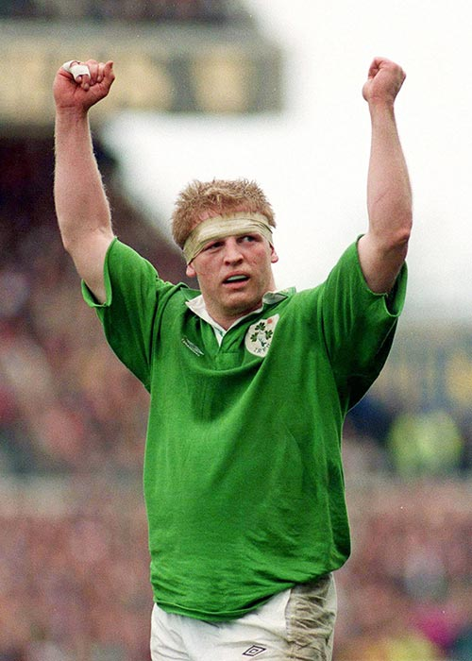
- Christy Condon 2007-14
Dolphin appearances 106 Tries 8
Dolphin Senior Captain 2013-14

Christy joined from Midleton and was such an important front row player for six seasons. Member of the Hundred Club, he made 6 appearances for the Irish Club side and was an unused substitute on another occasion. Based on these performances he earned a training contract and later a development contract with Munster.
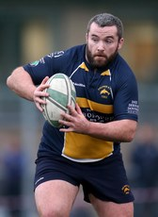
- Chris Rowe 2008- 2016

Dolphin appearances 120 Tries 14
Dolphin Senior Captain 2015-16

Former Wales U21 international, made 120 appearances in 8 seasons, while he stopped playing in 2016, he took over as Head Coach with Barry Keeshan as backs coach in 2017 to keep Dolphin from relegation.
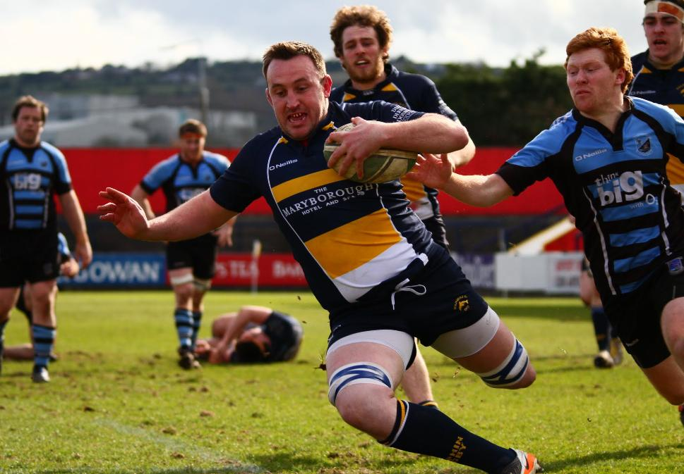

- Rob O’ Herlihy 2010 -18
Dolphin appearances 122 Tries 3
Joined from PBC and established himself in the Senior side in the first season and made 122 appearances over the following eight seasons. Equally comfortable in the 2nd row or backrow.
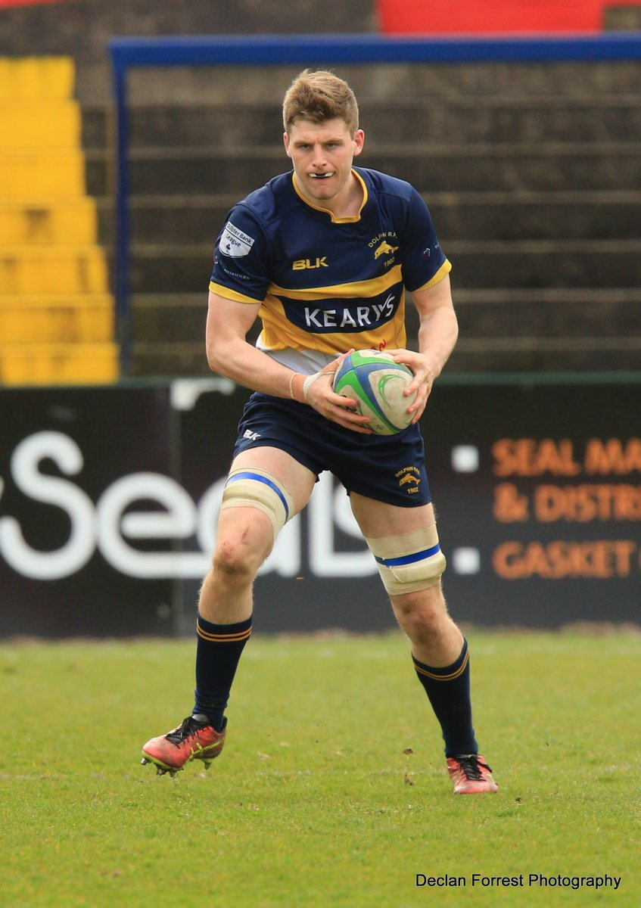

- Dave Pomeroy 1996-2007

Dolphin appearances 106 Tries 9
Dolphin Senior Captain 2002-03 & 2004-04

Dave was the first Dolphin player to reach 100 appearances. He was on the first side to reach Division One and led the team to victory in the Division 2 Final six years later.
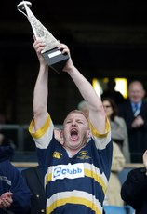

- John Quill 2010 - 2015

Dolphin appearances 50 Tries 10
USA Eagles caps 37 Tries 5

Always looking to make a career from rugby, played in USA and UK returning each time to Dolphin where he was player of the year on a couple of occasions. Selected for 2 Rugby World Cups, his favourite try was no doubt the one he scored against Ireland.
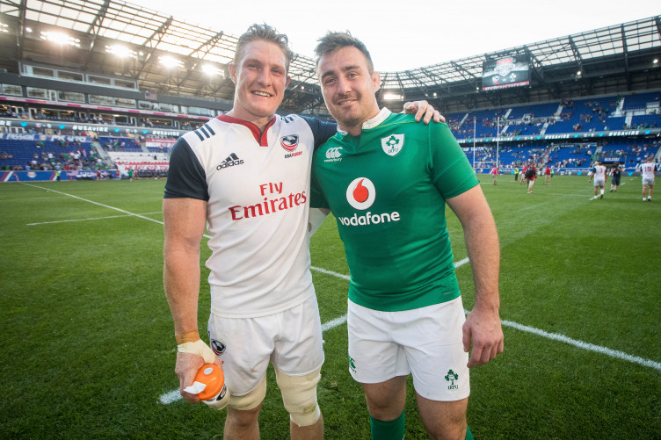

- John Fitzgerald 2013-2020

Dolphin appearances 67 Tries 5
Dolphin Senior Captain 2014-15 & 2016-17

Former Cork Minor Hurler & Munster U20 captain. Very committed to the club, when he was working in Dublin he was still playing with Dolphin, Canada might be a bit of a push though.

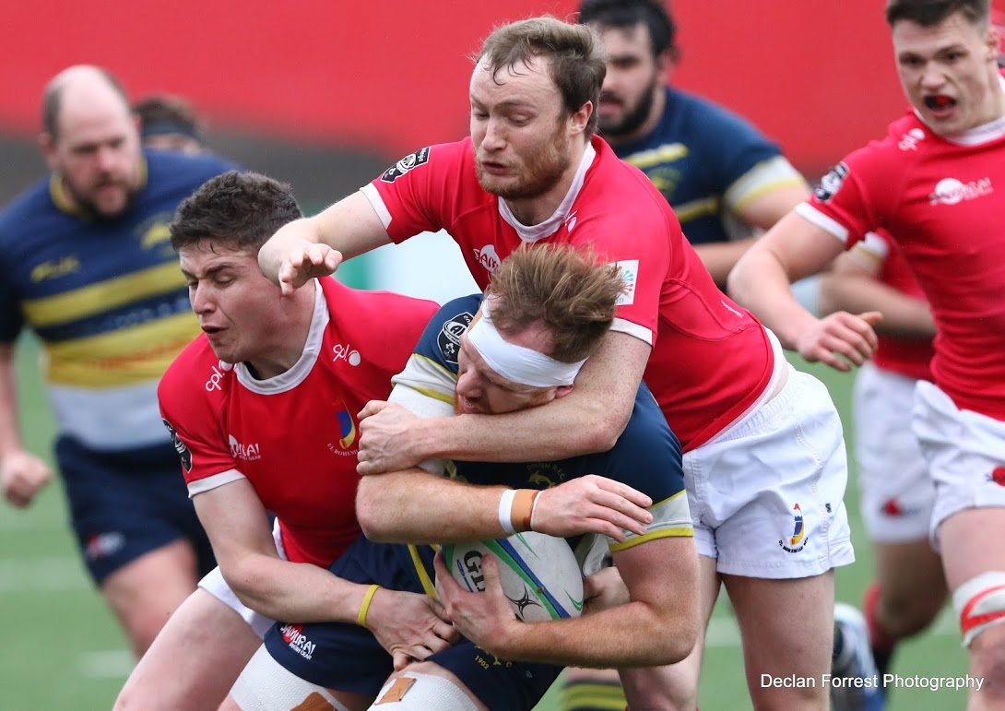

Substitutes

16) Conor Twomey 1998-2004

Dolphin appearances 42 Tries 7

Very accomplished Hooker went on to become a very high-level coach.
Head Coach UCC (4 seasons), Munster U20, Club International & Irish Universities. Assistant Coach Ireland U19 & 20’s.

17) Philip Scott 1994-2001

Dolphin appearances 57 Tries 1
Dolphin Senior Captain 1996-97 & 1997-98

Club captain in two of the most important years in the club’s history- promotion to Division 1 for the first time and the first season in Division 1.
No other family has had as many representatives in the AIL for Dolphin as the Scott’s with his brother Peter and his sons Brian & Cian (pictured at Prop- where else)
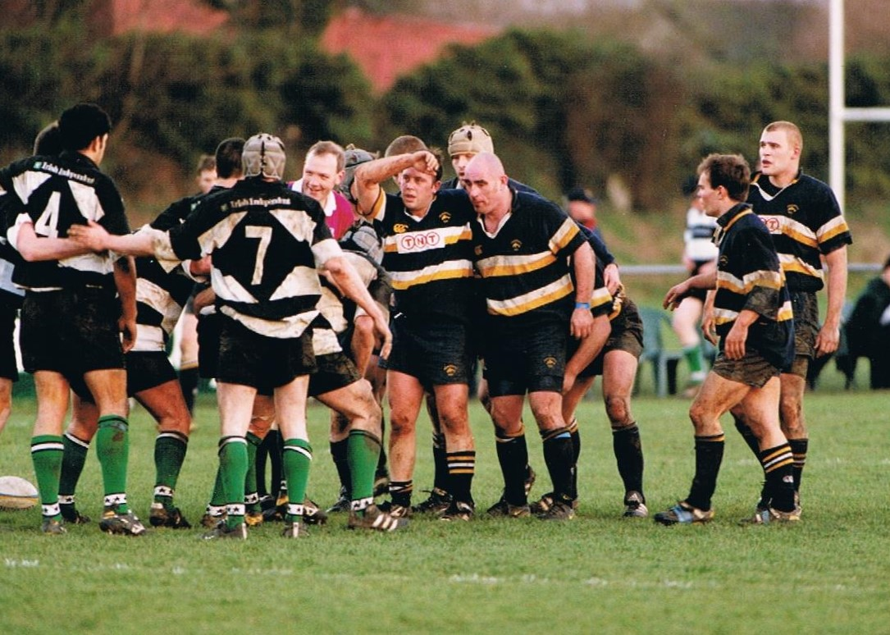
18) John O’Sullivan 2000-07

Dolphin appearances 96 Tries 4

What is it with West Cork props and finishing on 96 appearances, like Eddie Knowles, Kinsale man John O’Sullivan (on left) made 96 appearances, however it took him two seasons less.
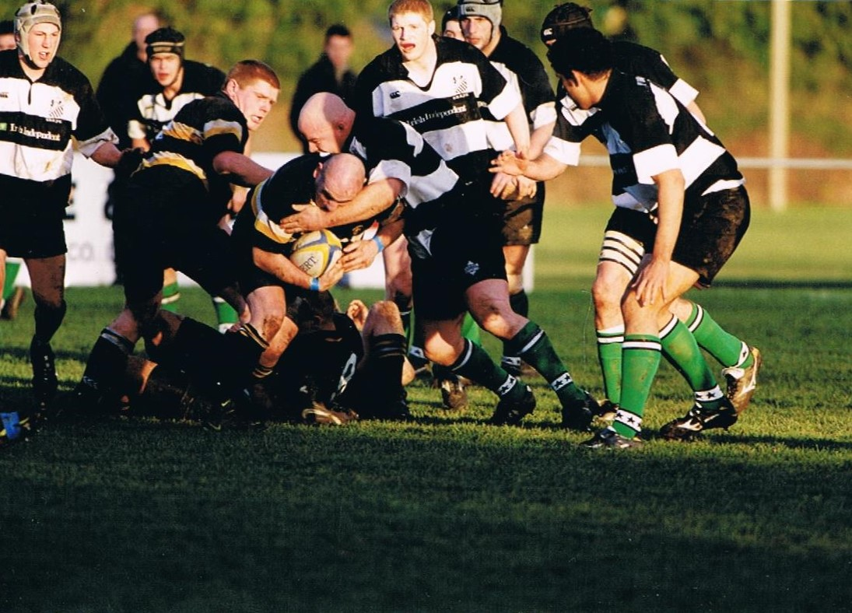

19) Shane Madigan 2001-04
Dolphin appearances 38 Tries 9

No.6 - Shane had 3 very good seasons with Dolphin before transferring to Blackrock College.

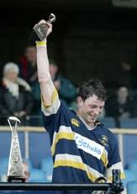
20) Steve Jackson 1997-98

Dolphin appearances 11 Tries 2

Represented NZ at U17 & U19 + New Zealand Maoris. Decided to come to Dolphin on his OE (oversea experience) playing No 8 in Dolphin’s first season in Division 1.
Went into coaching on retiring as a player and is currently the Head Coach of Samoa.

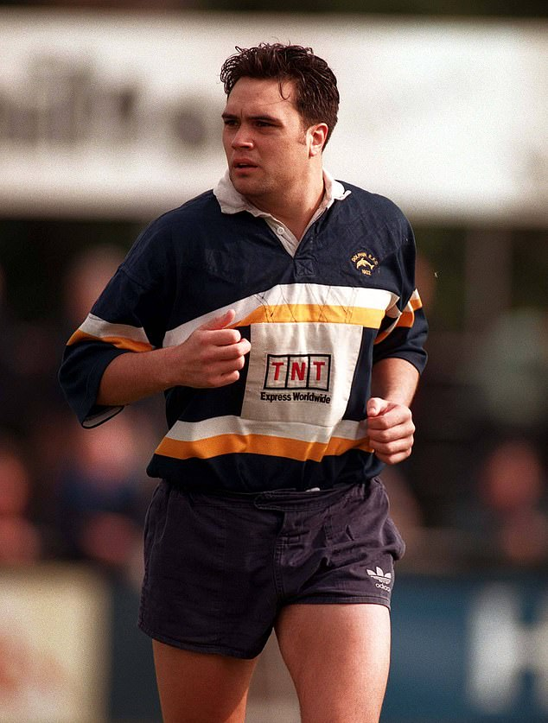
21) Sam Cronin 2009-2010
Dolphin appearances 17 Tries 4
Played just the one season with Dolphin and made a big impression. He captained the Irish Club side that season, forming an all Dolphin partnership with Keesh, Eric Moloney & Barry O’ Mahony also featuring, Christy Condon being on the bench the same day.
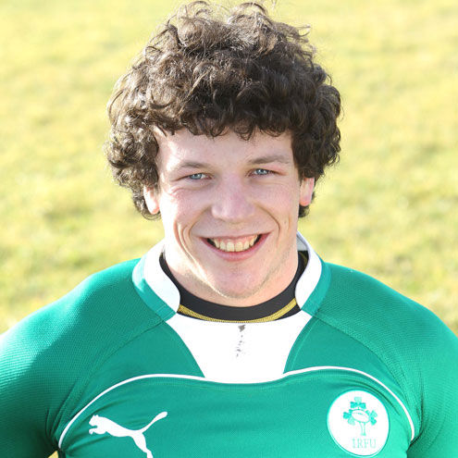
22) John O’ Mahony 1997 -2007

Dolphin appearances 126 Tries 9 Pens 289 Cons 144 DG 9

A very reliable and valuable player for may seasons, he was the 3rd player to score 1000 points in AIL history (the first Dolphin man to do so)

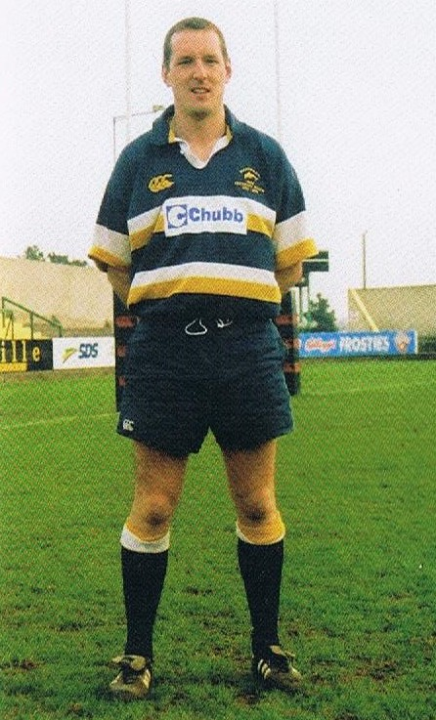

23) Barry O’Neill 1992-2004

Dolphin appearances 88 Tries 17 Pens 9 Cons 4 Dg 2
Dolphin Senior Captain 1994-95 & 1995-96

His appearances were fairly equally split between centre & full back with a couple of games on the wing as well. His AIL appearances earned him a short-term contract with Munster.
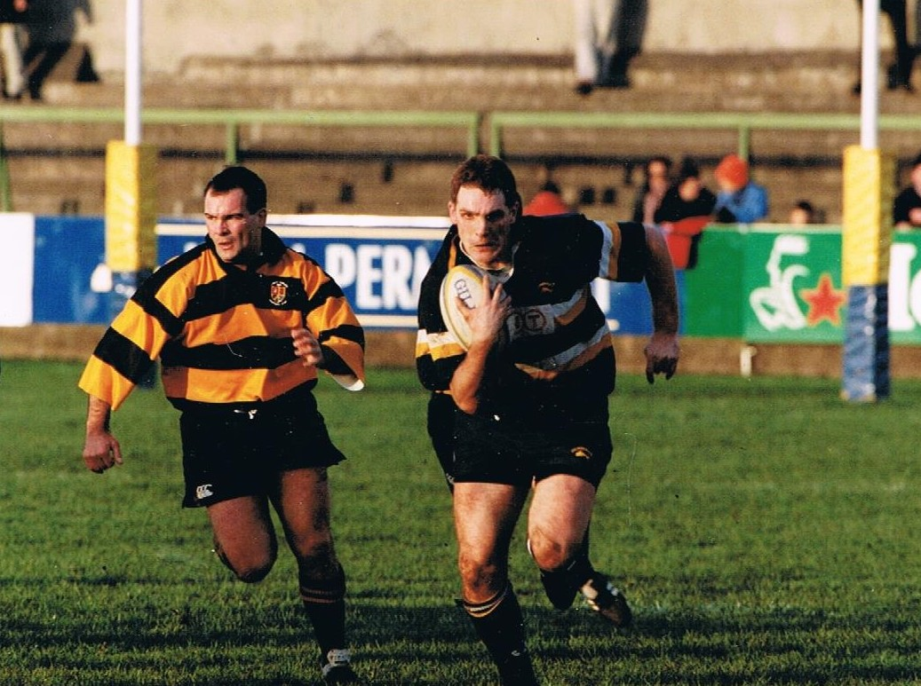

Some of the more interesting calls

14. Mike Pettman v Barry O’Neill
Two very talented and versatile players, both were nominated in at least 2 positions.
8. Steve Jackson had a long career in professional rugby, had just the one season with Dolphin. John Fitz is a proud Dolphin man, a great player, there was an old adage, “Die for Dolphin” No matter how hard the tackle Fitzi was always up to play on, as it’s a Club team he got the nod.
17 Philip Scott v James Rochford. There was nothing between them, 19 years after his retirement, Philip makes most home games, just something that Rocky cannot match.

