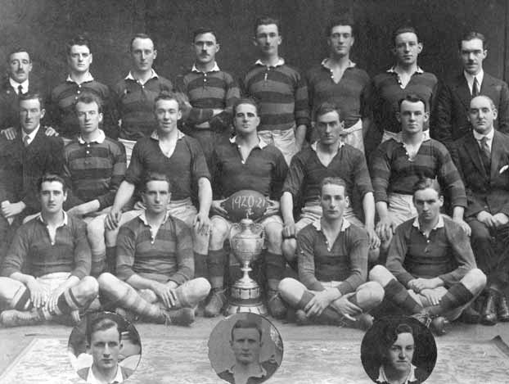

Back Row W J Hegarty (President) J Dorgan, D Keane, W Murphy, J O’Sullivan, P Kelleher J Mahony, W S O’Brien Ass Hon Sec.
Middle L F Daly, Hon Treas, J Bowen, M J Bradley, R J Coleman (Capt) T S O’Sullivan, T Cogan, F Thomas V Pres.
Sitting J O’Neill, R Long, J Wren, J Wellwood Inserts P Sheehan, G Studdart, M J Canty.

