Jack Clarke – International debut 30 years ago, and still playing
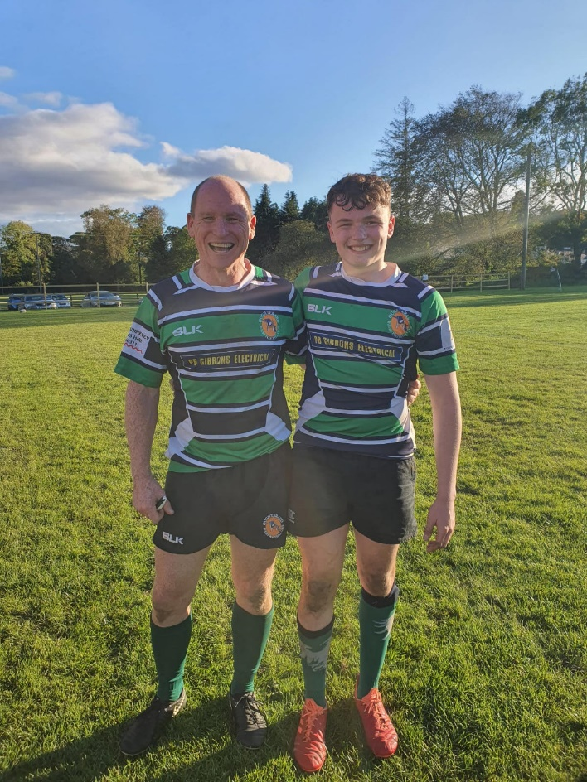
Jack Clarke made his International debut on 16-02-1991 v Wales, making it more memorable by scoring a try. Jack who also represented Ireland at the Javelin, played with the Irish Schools side when in Rockwell College before he joined Dolphin. While he was an U20 with an eye on Senior, he was still underage for U18 which was very unique that a former schools international could and did line out for Dolphin in the U18 Cup.
He captained Munster U/20’s and toured with Ireland to Italy 1989 (U21′s),Namibia in 1991 and New Zealand 1992. Jack was capped at every level available to him at the time, Schools, U/21, U/23, B, and Senior.
1991 was a Rugby World Cup year, a good year to peak, Jack starting on the wing in the Q/F against Australia.
In the closing minutes Ireland were behind, the ball was spread across the backline, full back Jim Staples hit the line and managed to kick ahead as he was tackled. Clarke & Campese followed the ball. David Campese was just the 2nd player internationally to reach 100 caps and a world record 64 test tries and Player of the 1991 RWC Tournament.
The Australian appeared to lean across and lost his footing, Jack had a perfect pick up but the cover caught him by the legs, he stayed upright and spotted Gordon Hamilton storming towards him. He held and past it to Hamilton, who ran half the pitch to score a try. Heartbreak was to follow almost immediately, another try for Australia and Ireland were out after a narrow 19-18 defeat.
https://www.youtube.com/watch?v=vqXXsOu5dfk the Hamilton Try.
Jack was selected for the following summers tour of New Zealand where he earned his sixth and final cap. His last representative outing of note came the following autumn, in Munster’s phenomenal Musgrave Park victory over the Wallabies.
Jack moved on from Cork, finally settling in Oughterard where he has two rugby playing children, Ben & Hannah.Jack continues to love the game and had been coaching Oughterard RFC who play J2 for many years and has continued to play. He was playing competitively until the lockdown, lining out beside Ben (pictured above) Not bad for a guy of 52. Yes fifty-two.
He continues to watch Dolphin results with great interest and has attended Munster games in Musgrave Park, joining some of his old friends for a pint.

