Capt Mick Dowling

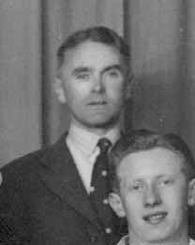

Dolphin’s best known referee took charge of 18 Internationals between 1947 & 1956. Only four referees had taken charge of more internationals by the 1980’s. He was Ireland’s first International referee after the 2nd World War, a regular at Murrayfield, taking charge of eight internationals there.
He won a Munster Junior Cup medal with Highfield before he moved to Dolphin to play Senior. Seventy years ago, between January & April 1951 he took charge of four 5 Nations internationals. In 1952 the visiting Springboks said he was the best referee they played under in their tour. He had been on duty for South Africa’s fixtures v Scotland, France, Ulster and the Barbarians.
He also was the referee for quite a number of the Services Fixtures, British Army v Navy and Air Force and took charge of five Munster Senior Cup finals between 1942 & 1954. Now you are used to seeing International referees also doing just Pro 14, Top 14 or English Premiership games, back then Capt Dowling followed up an International with doing a Minor Cup semi final the following week

