75th Anniversary of first cap 8th February 1947
Bertie O’Hanlon (Irish International No. 559)
1947-50 12 caps 3 Tries
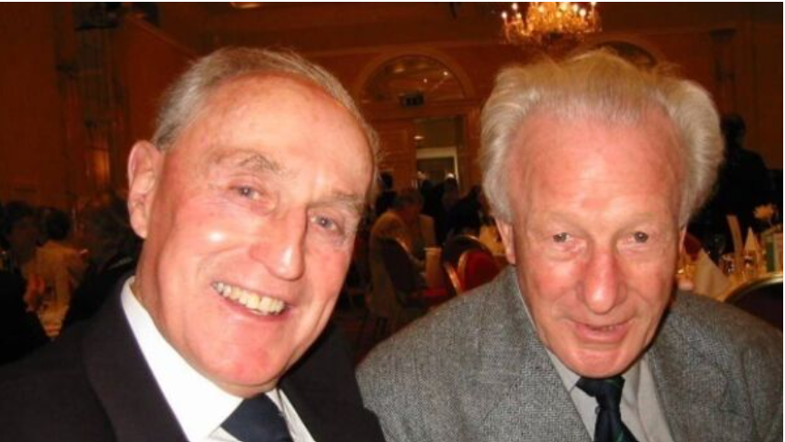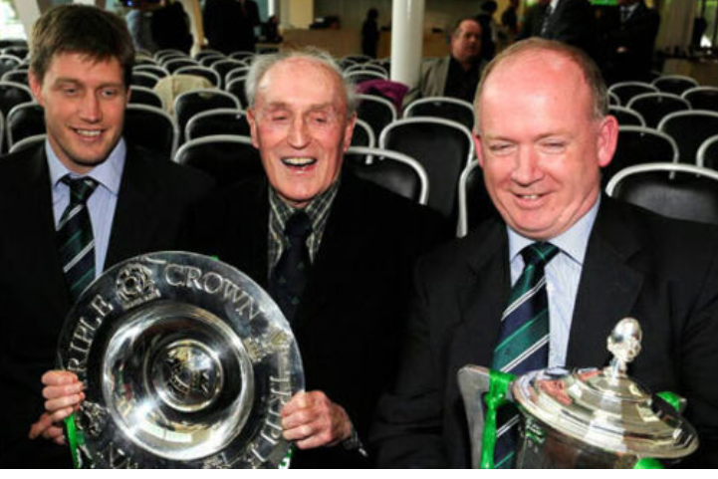
1948 GS Winners Bertie O’Hanlan & Jack Kyle - 2009 GS Winners, R O’Gara, Bertie O’Hanlon D Kidney
Born in Ballyclough, Mallow, his father was dispensary doctor, on his death, the family moved to Cork in 1932 he was introduced to rugby at PBC. At the age of twelve, he became a boarder at Rockwell College. An all-round sportsman, he also represented Rockwell at Gaelic Football and was South of Ireland sprint champion over 100 and 220 yards and long jump champion for two years.
Played scrum half on Junior cup side that also contained Dr Paddy Hillary President of Ireland
He moved to centre and played Senior Schools Cup for three years and in 1942 beat PBC in the final with Gerald Aherne at scrum half.
Rockwell College failed to retain the trophy in 1943, he agreed to play with Cork Constitution in the Munster Senior Cup. They sent a taxi to the school for him to bring him to Mardyke to play in MSC semi-final. They won and while he was a substitute for the final v the Army he still got his first MSC medal, he also won Minor Cup and League medals. He played in the Munster Junior Cup with Clonmel, but they were defeated in the final.
With all his friends in Dolphin he joined Dolphin in September 1943 but missed much of the season through injury. In 1945 Dolphin retained the MSC so Bertie claimed his second medal. Also, in 1945 he made his Munster debut, scoring two tries and playing against each of the other three provinces. Interestingly he played centre for Munster and later wing for Ireland.
He scored two tries on his international debut, a 22-0 victory over England on 8/2/1947. Barney Mullen tried a drop goal, it screwed off his foot and Bertie won race for touchdown. There was no luck involved in second try he collected a kick on his own 10-yard line, beat defender after defender to score by the posts. He was just the 2nd Irish player to score two tries on his debut.

He was selected thirteen times for Ireland but had to cry off against Australia in 1947 because of injury. He had a short international career of four seasons (1947-1950) that was littered with honours, two Triple Crown’s and the Grand Slam. The pinnacle of his career should have been the Lions tour of New Zealand & Australia in 1950, in those days the tours lasted 6 months and he was asked by the IRFU to allow his name to go forward but his employers would not release him.
In 1948 has was Dolphin vice-captain and they were victorious in the MSC, and he won his 3rd MSC medal.
in 1951 he dislocated his shoulder in the Senior Cup v Cork Constitution, it never knitted, and his career was over at 28.
He died in 2016 at 91, the last surviving member of the 1948 Grand Slam Team.

