D B O’Loughlin – Dolphin’s War Time International
D B O’Loughlin (David Bonaventure) was born in Glenbeigh, Co Kerry in July 1916. When he was attending UCC he won the first of his six official caps for Ireland in 1938. That season he played against England, Wales and Scotland, in the opening game in the front row, 2nd game in the 2nd row and the third game he played in the backrow.
There were no Internationals between 11/03/1939 & 25/01/1947. In their absence, on April 1,1939, Sam Walker's 1938 touring side to South Africa reconvened to play an unofficial Lions match against their manager, B C "Jock" Hartley's XV at Ravenhill in Belfast and O’Loughlin was on Hartley’s side.
He played on an Ireland XV that played the British Combined Services in 1943,1944 & 1945. In 1946 he played in the two “Victory Internationals” against England & France, the unofficial war time internationals, he was one of three players from the pre war era to play.
He won Munster Senior Cup medals with UCC in 1937 & 1939, following his transfer to Dolphin in 1940-41 he won a Charity Cup Medal and followed that up with two further Munster Senior Cup medals with Dolphin in successive years 1944 + 1945. He was Garryowen captain for the 1948-49 season.
He was also very involved with Clanwilliam, he worked for a period in Cleeves Creamery in Tipperary. He actually played for Clanwilliam in the Mansergh Cup, the Sunday before he made his Irish debut in 1938.
Following his retirement from playing he was soon involved with Munster & Ireland sides again, this time as a selector for the 1949-50, 1950-51 and 1954-1955 seasons. He was manager of the Golden Vale Co-Op when he passed away just days after his 55th Birthday.
The Irish rugby team that played against England on 12th February 1938 Debutant D B O’Loughlin - Far right back row- E Ryan another Dolphin man 2nd from left middle row

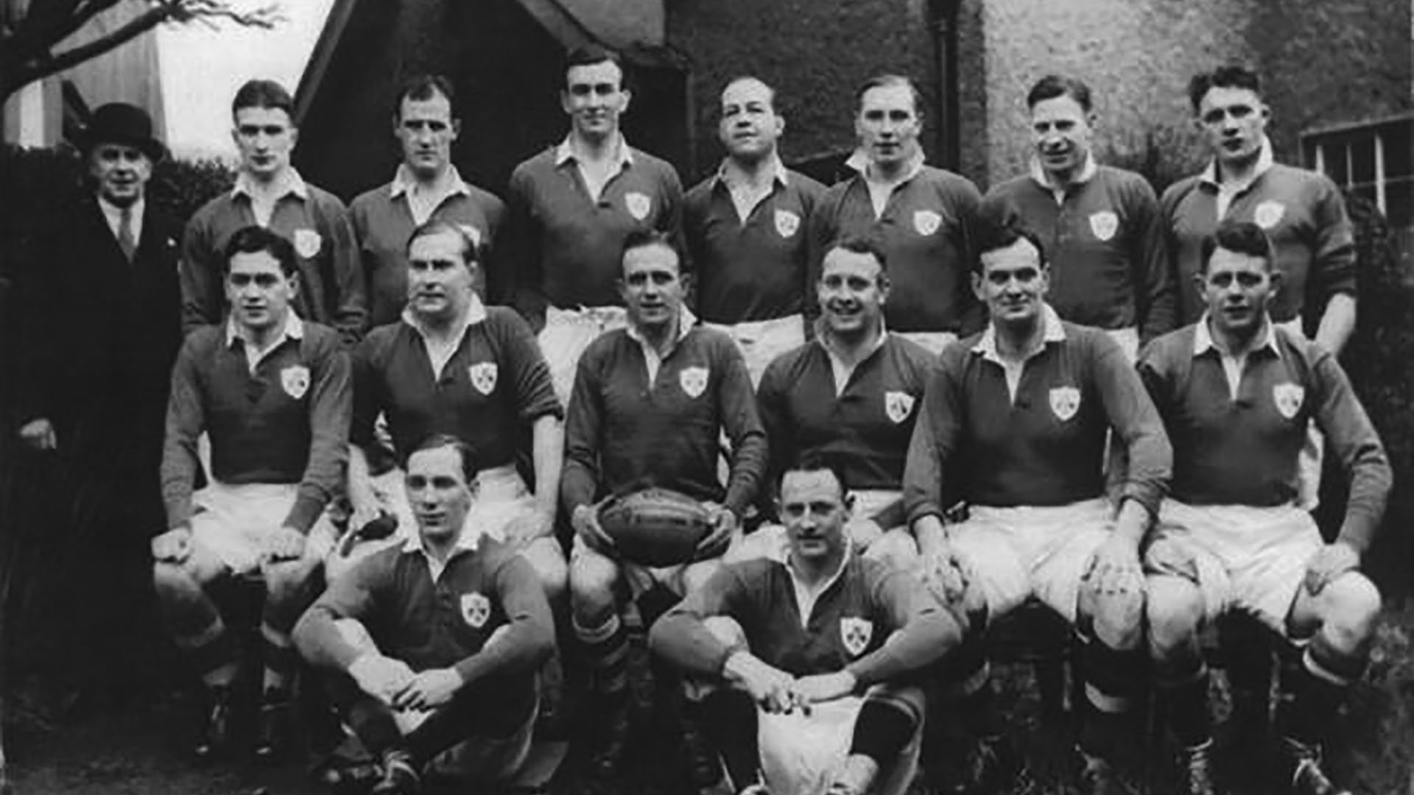

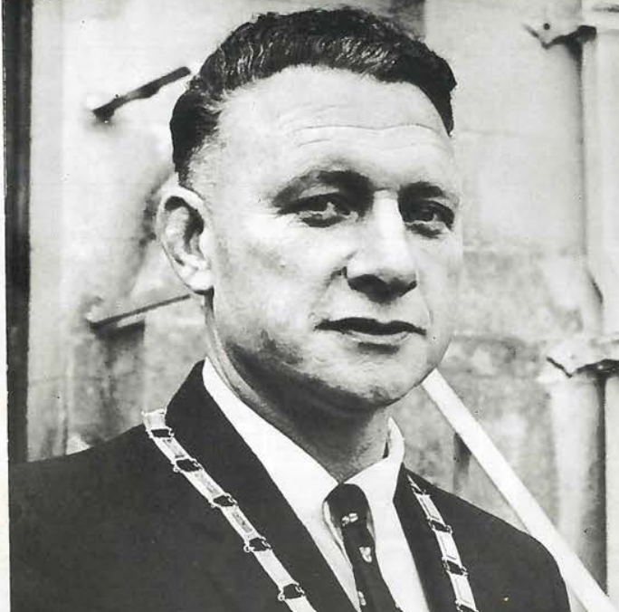
President of Blackrock College Union

