23.01.1982 Mick Kiernan’s International Debut

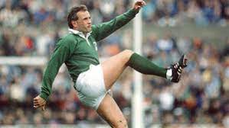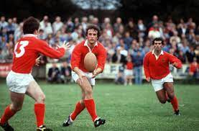

Mick Kiernan first came to prominence in 1976 as out half on the Munster Schools Junior Cup winning PBC side, following up with a Senior Cup medal winners medal He represented Ireland Schools for two seasons before he joined Dolphin.
He was also a very talented athlete, in 1981 he managed to combine both, he toured South Africa with the Irish Squad, was on the Munster side that defeated Australia, was National 200m champion and represented Ireland v Scotland in athletics. In his first season with Dolphin he made three Munster appearances and the following season his Irish Senior debut.
The first match of the 1982 6 Nations championship was cancelled because of snow. Kiernan, just turned 20, was selected on the bench for Wales on 23.01.82, his chance came early due to a broken leg for the unfortunate David Irwin. Ireland won 20-12 and went on to win the Triple Crown, for the first time in 33 years.
In 1983 he toured New Zealand with the B & I Lions, starting in three tests.
In November 1984 Ireland played Australia, Moss Finn was the designated kicker and went down injured, Mick Kiernan took over. Not having taken a kick in his 13 previous Internationals, he stepped forward and was 3/3 on the day.
Fast forward to England 1985, having already defeated Scotland & Wales, the sides were level 10-10 in the dying minutes, Mick Kiernan was standing at first receiver, as Jim Sherwin called it on RTE Radio, ‘Drop-goal on. Drop-goal taken. Drop-goal good! Kiernan was the hero. They won the Triple Crown and Championship as five Kiernan penalties gave Ireland a 15-15 draw with France.
He earned further Lions honours in 1986 against the Rest of The World in a game celebrating the centenary of the International Board.
In 1987 he appeared in the inaugural Rugby World Cup in New Zealand and Australia. He is pictured below scoring a try against Australia in the RWC Q/F in Sydney 07.06.1987.
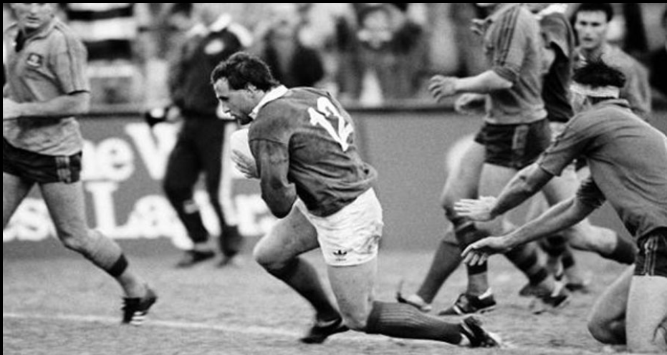
When he retired, Kiernan was Ireland’s fourth highest points scorer of all time, with 308 points (6 tries, 40 con,6 dg, 62pen) in 46 International appearances. He scored a record 65 points for Ireland in their 1985 tour to Japan and in the inaugural World Cup (1987) was also Ireland’s top scorer with 36 points.
He came out of retirement in 1994, persuaded by the Senior coach Phil O’Callaghan to come back for the last four games of the season as Dolphin needed to win at least three to remain in Division 2. Three victories later, Division 2 status retained, Kiernan finally got to hang up the boots after an victory away in Ballina on 09/04/1994.
Sporting Relationships
Parents
Jim - Represented Munster at Full Back, also played Cricket for Ireland
Angela (Lane) played in 2 All Ireland Camogie Finals with Cork
Uncles
Tom Kiernan – 59 Caps (including 5 B + I Lions )
Mick Lane – 19 Caps (including 2 B + I Lions )
Richard (Dick) Lane Irish 60 yards + 100 yards (twice) Champion
Gerald Reidy - 5 Caps
Wales – Debuts
Mick Kiernan - Ireland Schools
Mick Kiernan – Ireland
Mick Lane - Ireland
Gerald Reidy - Ireland

