Mick Lane British & Irish Lion No. 329
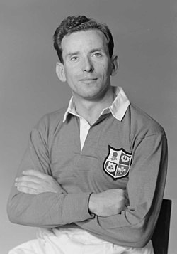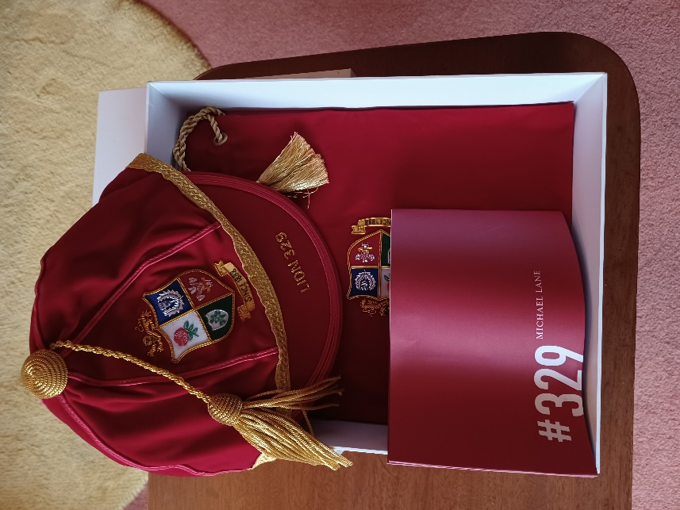
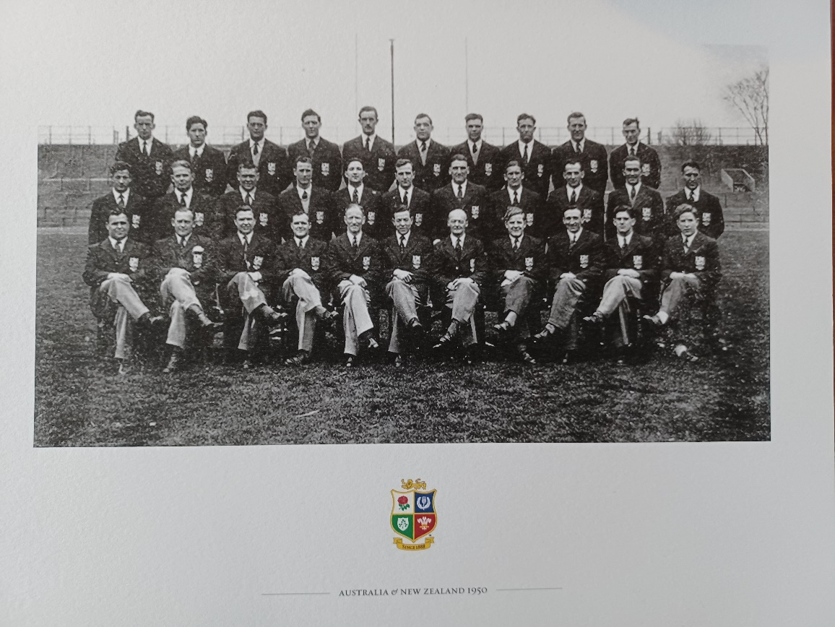
A couple of weeks ago, many former British & Irish Lions, or their families received a lovely surprise in the post, receiving a B & I cap. Mick Lane who was recently 95, was on the 1950 Tour to New Zealand & Australia. The UCC winger made his international debut for Ireland against Wales in March 1947 in the then Five Nations Championship
He missed out on the 1948 Grand Slam through injury. He was back for all four of Ireland’s matches in the 1949 Championship. They retained the Championship and the Triple Crown, narrowly missing out on back to back Grand Slams.
Another highlight for 1949 was his only appearance for the Barbarians during the Easter Tour against Cardiff, also scoring a try.
He impressed sufficiently in his four international appearances in 1950 to be selected for the B & I Lions Tour to New Zealand & Australia.He made a total of 11 appearances, scoring four tries on tour. A test winner against Australia and his appearance against New Zealand, resulted in a narrow loss.
He made three appearances in the 1951 Five Nations when Ireland once again won the International Championship. It would have been a second Grand Slam in four years had Wales not equalised to make it 3-3 in the final game at Cardiff Arms Park.
He played twice against South Africa in December that year, a test match for Ireland, and also with Munster. That was his only non Five Nations International.
In the second of his two appearances in the 1952 Five Nations, Lane scored his only points for Ireland with a try against Scotland. His final (17th) appearance for Ireland came during the 1953 Five Nations. The former Irish Sprint Champion transferred to Dolphin the following season.
It was interesting to note that in his 17 Ireland appearances, the opposite winger in seven games were Dolphin men, Bertie O’Hanlon & Maurice Mortell.
His nephew Mick Kiernan, himself an Irish 200m champion also played for the B & I Lions. Mick Lanes sister Angela was married to Jim Kiernan. Another team mate, Gerald Reidy was married to Jim Kiernan’s sister Anne.
He played for Dolphin for just two seasons, at the end of the 1954-55 season both he and fellow B & I Lions player J S McCarthy retired.
He found himself opposite Jim Kiernan in December 1954 when playing for Dolphin v UCC in the Cork Charity Cup Final. Dolphin led 3-0 until seven minutes to go when Kiernan put over an equalising penalty from near the side-line, 35 yards out. The Cork Examiner reported an unusual event, when the equalising kick went over, one of the College players fainted with excitement, but was able to continue. Dolphin won the replay.
Dolphin also defeated UCC in the Munster Senior League final, while having played in earlier rounds, Mick Lane was unavailable to play in the final.
Lane was inducted into the Rugby Writers of Ireland Hall of Fame in 2011.
His sons, Joe & Martin played Senior for Dolphin, Martin is currently the clubs Grounds Chairman and a member of the Club Management Committee.

