James Coughlan, is he Ireland’s best uncapped player
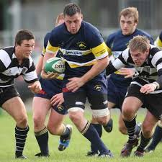

James Coughlan was described by former Munster forwards coach Laurie Fisher as “the best Irish player in the professional era never to have played a Test match.”
“He must go down as one of the best players not to win an Ireland cap” The 42.
“It is odd that one of Munster’s most consistent players never got a look-in with the Test side “ David Wallace- having played with Coughlan for 6 years.
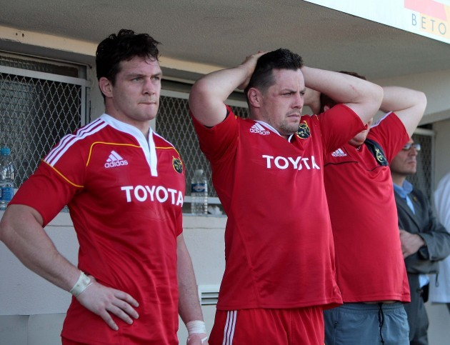
Wallace & Coughlan in 2011 in Brive- where James is now Forwards Coach.
From time to time an article would appear on the internet, what is the best non Irish capped 15, one name would regularly appear, James Coughlan.
The Munster Player of the Year was awarded for the first time in 2006-07. In 2010-11, the Munster Player of the Year was James Coughlan, fighting off competition from fellow nominees Keith Earls, Doug Howlett and Ronan O’Gara.
He was the only winner apart from Tyler Bleyendaal who was not an Ireland International.
It is interesting to note that B + I Lions Donncha O’Callaghan (2005/2009), Paul O’Connell (2005/ 2009/2013) and Simon Zebo (2013) never won the Munster Player of the Year Award.
Looking at the Munster Squad for 2010-11, twenty eight of the squad are full internationals. This included Niall Ronan (4) Damien Varley (3) Dave Foley (2) Denis Hurley (1)
James was also on the short list of three for the award in both 2012 & 2014.
He made 139 appearances for Munster and scored 13 tries, he captained the Munster side that defeated Australia 15-6 in November 2010. He was the Munster No 8 that season that beat Leinster in the Magners League Final.
His only appearance in an Irish Senior Jersey was in an uncapped game against the Barbarians in May 2012, other players who featured in an Irish Jersey for the first time included Simon Zebo ,Craig Gilroy, Ronan Loughney, Paul Marshall and the late Nevin Spence who died in a tragic accident just four months later.
In 2013-14 in a Munster v Leinster fixture, the only non capped starters were Duncan Williams James Coughlan & future international Dave Kearney.

Looking at his inclusion in Ireland squads
- In 2012 he was called into the Irish squad to replace Leo Cullen
- In 2013 was added to the 6 Nations Squad but Iain Henderson got the place on the bench.
- In November 13 he was named in the November International Squad, Joe Schmidt’s first squad as coach, one of three uncapped players, both Dave Kearney & Jack McGrath made their debut’s.
In Jan 2014 he did not make the 6 Nations Squad, Robin Copeland, the Cardiff No 8 joining Munster in the summer was included. (Copeland then aged 27 earned his only cap in the November series)
Munster acceded to his request for release from his contract to join Pau, some people held the view that at 33 he was pushing on .
He proved them wrong, at the end of his first season with Pau in which they were promoted to the Top 14, winning by 11 points, he collected the 2014-15 Pro D2 player of the season award.
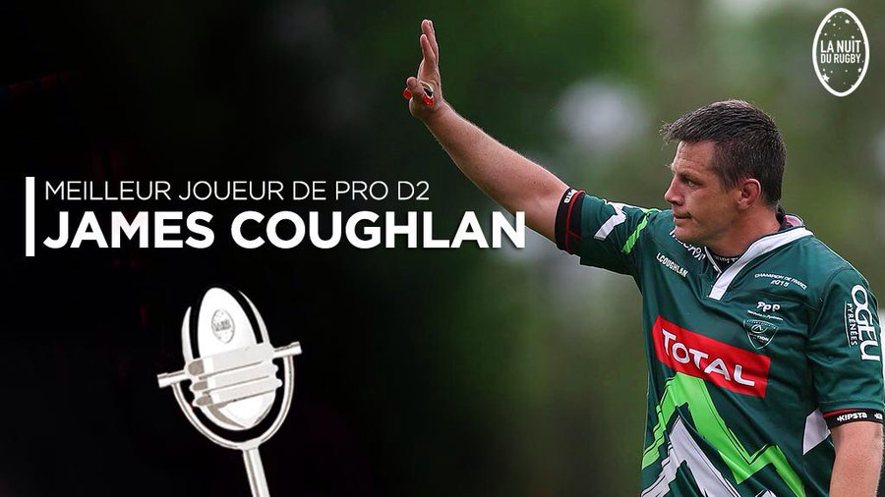
He continued to star for Pau for another two seasons, was still a regular starter at 36.
Upon retirement, Coughlan immediately progressed into coaching with Pau's academy. During this time, 27 of the 30 players in the academy went on to sign professional contracts. After two years with Pau, Coughlan joined Aix -En-Provence as a forwards coach for the 2019–20 season, and oversaw a transformation of the team's defence from the fifth worst to the fifth best, as well as turning the team's scrum from the fourth worst to the second best in the Pro D2. Coughlan's work caught the attention of Top 14 club Brive and he joined the club in July 2020 ahead of the 2020–21 season. Ahead of the 2021–22 season, Coughlan, having left Brive, joined another French Top 14 club, Toulon as their defence coach and was placed in temporary charge of the team after head coach Patrice Collazo left in October 2021.

