Gerry Harrington 1960- 2021
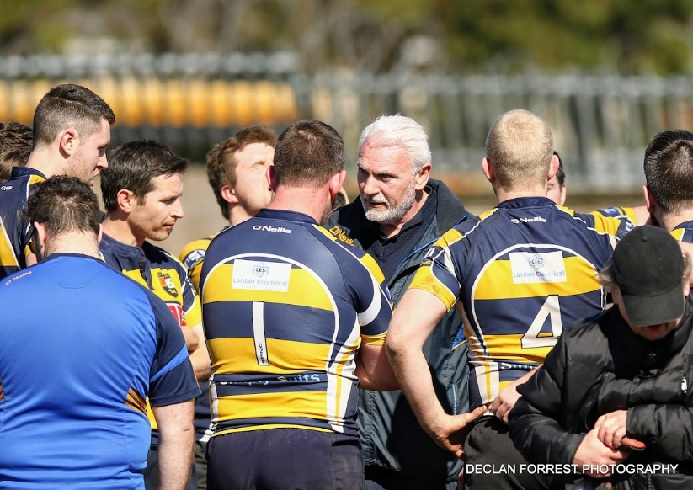
Gerry, as his friends would know was from Castletownbere, and proud of it. His parents moved to Finchley in London when he was 3 or 4 but Gerry was home every summer growing up and used to work on the family farm or on the boats. He was a very accomplished swimmer, on the radar of the British Swim Association, following an injury he decided to concentrate on rugby and spent eight years on the Saracens 1st side before returning to Cork when he was 30. The period of his life in England left him sounding anything but a West Cork man, I can remember many times when he would say to me “Ger, will you tell them I am from Castletownbere”.
He had three passions in life, his family, rugby and The Arsenal.
It is sad that you only learn things about someone at their funeral. While we all knew of his love for Áine and the family, but we did not know how soon they realised they were the one for each other, in that they were engaged after five weeks and married after 18 months.
He played Senior for Dolphin for a period before taking up refereeing for a couple of seasons before he started coaching. His abilities as coach come to the fore with the success of his U 15 squad in 2012-13 . They almost had the perfect season, winning 17/18 games, the sole blemish being the league semi-final to Skibbereen, but they got revenge in defeating them in the cup final.
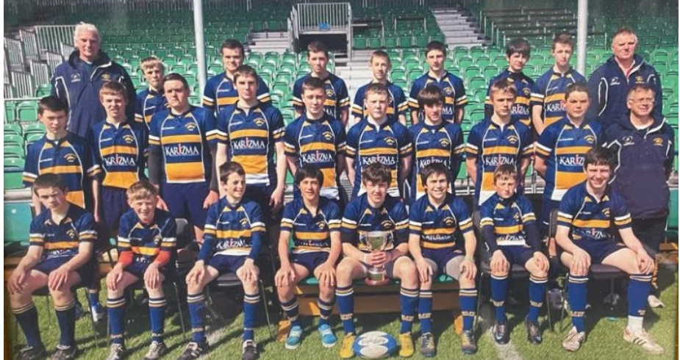

Gerry was the instigator of the U15 + U16 Tours in 2013 +14 to Wales + England playing Penclawdd Tonyrefail and Newbridge. Many of the parents of this group showed their appreciation to his dedication and commitment by attending the Services.
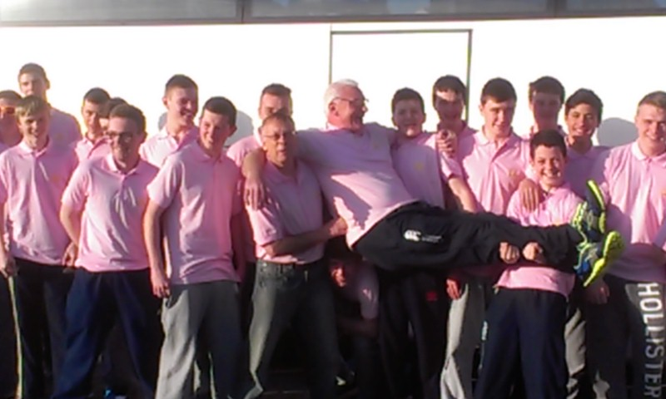
He moved to coaching adult sides, starting with the J2’s. He had a couple of successful seasons with them, bringing great structure, the players looking forward to pre-season as it would mean the legendary bonding sessions in West Cork. He joined Steve Ford’s Senior set up as a specialist coach and responsibility for the J1’s. Following a few seasons where fielding a J1 side was a problem, Gerry had them working together as the most successful J1 side for years. He was invited into the Sundays Well set up as a Specialist Coach for a couple of seasons before his illness took over.

Hopefully Áine and the family will have taken solace from the numbers who formed the guard of honour at Dennehy’s Cross Church. The Dolphin members, the J2’s and Cait’s teammates in addition to the Sundays Well players he most recently coached, but there was no representative from The Arsenal.
Liam in his eulogy, finished by quoting Gerry speaking at his father’s funeral, when he finished simply by saying “ thanks Dad”, on behalf of all the players he coached and all his many friends in Dolphin, “Thanks Gerry”
Ger Hodkinson

